**PROJECT PLANNING PHASE**

**PROJECT MILESTONE AND ACTIVITY**

**PROJECT MILESTONE:**

|  |  |  |  |
| --- | --- | --- | --- |
| **S.NO** | **ACTIVITY TITLE** | **ACTIVITY DESCRIPTION** | **DURATION** |
| 1. | **Understanding the project requirements** | Form a team and create the repository in GitHub. Assign task for each member and educate them to access the GitHub and IBM Career Education | 1 week |
| 2. | **Starting of the project** | Advice student to attend the sessions in IBM portals. Encourage them to create and develop a rough diagram based on the project description and gather information of IOT and IBM project. | 1 week |
| 3. | **Attending sessions** | It is necessary for the team leader and the team members to watch and learn from the sessions provided by IBM and NalaiyaThiran and must gain access of MIT License for their project. | 1 week |
| 4. | **Budget planning and scope of the project** | Plan the budget & analyse the use of IOT in the project with the team to predict the favourability of the customer to buy the product for the efficient use of it among the environment. | 1 week |

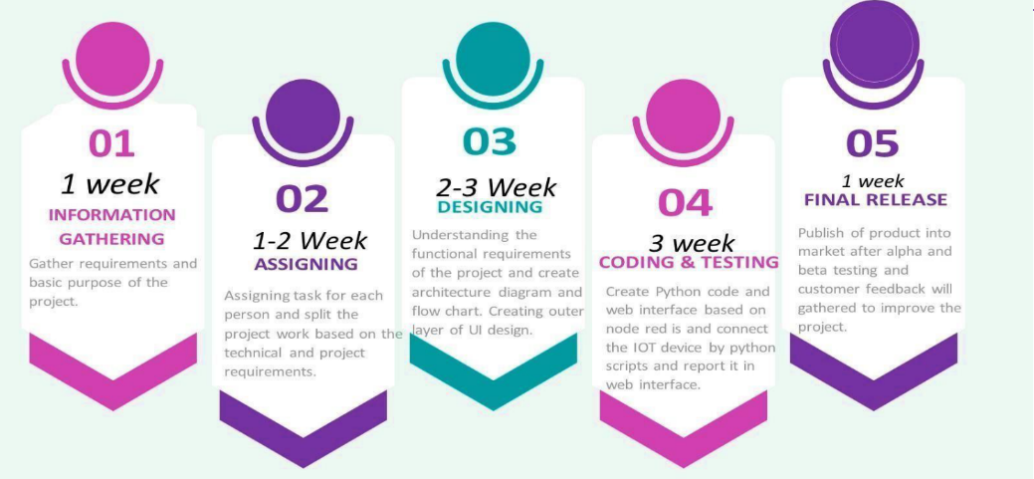

**ACTIVITY LIST:**